

**School of Computer Science and Engineering**

**J Component report**

**Programme : <<B.Tech(CSE with AIML)>>**

**Course Title : <<INTERNET AND WEB PROGRAMMING>>**

**Course Code: <<CSE3002>>**

**Slot : << B1>>**

**Title: << Tourist Place Recommendation System >>**

**Team Members: <<Devanshu Khemka | 20BAI1319>>**

**<<Hardik Kathuria | 20BAI1048>>**

**<<Sarvesh Sanjay Chandak | 20BAI1221>>**

**<<Krish Bagga | 20BAI1044>>**

**Faculty:** <<Prasad M>> **Sign:**

**Date:**

**INDEX**

|  |  |  |
| --- | --- | --- |
| **SI**  **No.** | **CONTENT** | **PAGE No.** |
| 1. | ACKNOWLEDGMENT | 3 |
| 2**.** | ABSTRACT | 4 |
| 3. | (i)INTRODUCTION  (ii)Existing system  (iii)Proposed methodology | 5-8 |
| 4. | BLOCK DIAGRAM | 9 |
| 5 | SYSTEM ARCHITECTURE | 10 |
| 6. | MODULES | 11-13 |
| 7. | TECHNOLOGIES AND  INTEGRATION | 14-17 |
| 8. | IMPLEMENTATION DETAILS (SOFTWARE USED) | 18 |
| 10. | CONCLUSION AND FUTURE  ENHANCEMENTS | 19 |
| 11. | REFERENCES | 20 |
| 13. | SCREENSHOT OF DATABASE AND WEBPAGE | 21-27 |

**ACKNOWLEDGMENT**

"It is not possible to prepare a project report without the assistance and encouragement of other people. This one is certainly no exception.

On the very outset of this report, we would like to extend our sincere & heartfelt obligation towards all the personages who have helped us in this endeavor. Without their active guidance, help, cooperation & encouragement, we would not have made headway in the project. We are ineffably indebted to our faculty Dr. Prasad M for her conscientious guidance and encouragement to accomplish this assignment in its presently.

We extend our gratitude to VIT Chennai for giving us this opportunity. We also acknowledge with a deep sense of reverence, our gratitude towards our parents and members of our family, who have always supported us morally as well as economically.

At last but not least gratitude goes to all of our friends who directly or indirectly helped us to complete this project report. Any emission in this brief acknowledgement does not mean lack of gratitude.

**ABSTRACT**

A user-based tourist place recommendation system is developed in this project. The recommendation system is constructed as an online application which is capable of generating a personalized list of preference attractions for the tourist. Here we have used HTML, CSS, JavaScript and php database for the implementation of the same. Firstly, the recommendation system starts with getting the status (single, couple, friends, family) of the user. After that the user gets the option to select the region from the list of 5 regions of India which they wanted to explore. On the basis of tourist status and the region they had selected, the recommendation process of tourist place provides them with the list of tourist attractions which they can explore. After exploring the list of attractions, the user can select one. On selecting a place, the website will take him to the payment page where he can get the idea of the total expences (including travelling, stays and meals). Also, one’s the user sign in to the website, the next time he just need to login and check his history as well.

# INTRODUCTION

Tourists can find tourism information on blogs, forums, websites of points of interest etc. However, information overflow can occur on the internet as there is still a lack of focus on the use of recommender technology in the tourism field. During a trip, tourists need to be able to obtain tour information in a timely manner whenever there are any changes in their planned trip. Recommendation of tour information is vital for users, for the recommendation system to succeed; it must be able to provide tourism information based on the user’s preferences and current location and so is our project. Our project is based on how an effective travel website will make us feel. It is based on a traveling website with fully-featured functions that will activate the traveling bug with vibrant imagery. It contains highlights of some important places along with high-quality photography and allows people to book their dream destination within their budgets. It also includes full customer support, vivid options, the customer can choose for there dream destination according to there status and region preference. We had included the images and vivid despcription of the places.

# OBJECTIVES

Objectives of Tourist Place recommendation are-

* To propose a framework for a place-based Tourist Recommender System.
* System will take the input as tourist status and interested region using JavaScript and php.
* Signed up user details recorded in the database. Nect time just supposed to log in.
* Specified region wise tourist places ranked depending upon their ratings and reviews.

.

* User will select particular region to view its details
* Selected region wise destination places based on the tourist status(single, couple, friends, family).
* Payment page with the total expences (including travel, stay and meals).

# EXISTING SYSTEM AND ITS LIMITATION

* In the existing system and the websites, The user doesn’t get any recommendation of the locations they would want to visit as per their preference
* The Existing system doesn’t allow the user to get a good recommendation of locations, the existing system lets the user choose interesting sites to visit  
  BUT what it doesn’t do is suggest some or top locations from different regions of the country or even different countries from around the world.

**PROPOSED SYSTEM**

* Proposed system is an automated Community Book house Centre.
* Proposed system deals with online registration of user to obtain services in library. For that first user needs to sign up in the system then after using proper login credentials he/she can made use to community room.
* Through our software user can add books, search books, renewal, update information, edit information, and return books in quick time.

# ADVANTAGES OF PROPOSED SYSTEM

Some of the advantages of Proposed system are-

* User friendly interface.
* User can check the places according to his status.
* Instead of checking in all over the nation, can look for a specific nation.
* Get the places ranked accordin to the ratings reviews and his status.
* User can give feedback of his experience.

**DATAFLOW DIAGRAM**

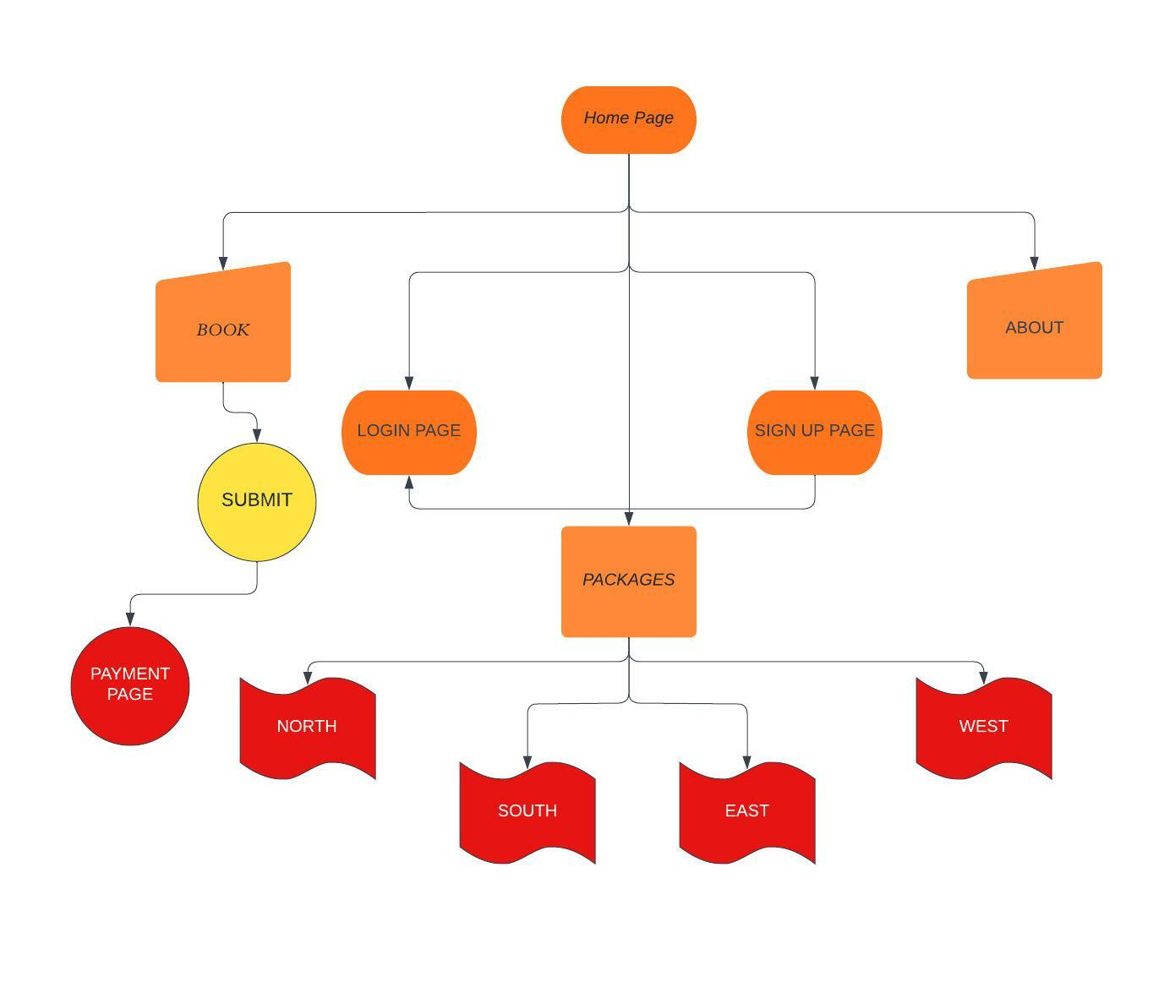

**SYSTEM ARCHITECTURE**

* When the user enters our website “TRAVEL.”, they get the option to either sign up or login in to an existing user profile to avail the facilities of our website and Travel’s tourist locations.
* After they login the entries of their activities(Like which locations they selected, date, time and what time they logged in and logged out)
* The user will select the location he wants to visit as per his/her choice and that information will be stored on his profile in the DATABASE.
* So, the internal level or schema is the part of the of the system architecture which is not to end users but the actual information of database is stored in it.
* External level or schema is the part visible to the users on their screen where they will have to first login and then enter their registered choices.

**MODULES**

## Module 1 – Registration

In this module, we are registering all the community members (users) in the system, they can register themselves through the sign-up option. Only the users who are registered can login and request for books.

Firstly, the users need to register themselves by going on the sign-up option and by filling all the required details they can easily register themselves and can request for the books they require.

If later the user feels to edit the profile, they can easily edit their information and also reset their password by going to profile > edit > submit.

Basically, we have two different registering portals, one is for the users and guest and the other one is for the admin department. From the admin login one can see the activities of all the users.

## Module 2 – Login and Logout

The default user of our Community Book house center is admin. Admin can see the community members information, add books, delete books, issue books and can also see the feedback given by other users.

A person can also login as guest if he/she just want to donate the book(s).

## Module 3 – Books

In this module we are displaying information from the database regarding all the books that are available in the community book house center.

The community members can search books by the book name as well as from book the department. After finding out the book they can request for the particular book by book id, which is unique. Then they can see the issue status in the “Issue Information” section.

Now, the admin can see and issue the book from the admin side by going to the “Book Request” page.

Now, if the respective member has returned the book, then admin can update the information by going to “Expire List” and by giving the community member’s username, book id and then pressing the submit button.

Admin can add and delete the book by admin side and the following data will be updated in the database of the community book house center at the back-end.

## Module 4 – Booking Page

This is one of the most important pages of our website. From this page, users can select place they want to visit, the number of days they are planning their trip for, their budget, etc. Our website offers multiple tour packages depending upon the place to visit, number of days, and budget. Using this page, user can select a package they are most comfortable with, pay the upfront amount, and that’s all, they are ready to enjoy!

For the places to visit, user can select between North India, South India, East India and West India. Selecting any of these displays famous places to visit. For example, if a user selects North India, he will be presented with the name of places like Vaishno Devi temple in Jammu and Kashmir, Taj Mahal in Agra, Rishikesh, Delhi, Pachmarhi, etc. Based on the user preferences, the places can be sorted in many ways, from adventure tour to religious places.

**TECHNOLOGIES AND INTEGRATION**

The tools and programming languages used in this project are as follows

1.PHP

PHP is an acronym for "PHP: Hypertext Preprocessor". It is a widely-used, open source scripting language. It scripts are executed on the server. It is free to download and use.it is powerful enough to be at the core of the biggest blogging system on the web (wordpress). It is deep enough to run large social networks. It is also easy enough to be a beginner’s first server side language.

2.HTML

HTML stands for Hyper Text Markup Language. It is the standard markup language for creating Web pages. It describes the structure of a Web page. It consists of a series of elements. It elements tell the browser how to display the content. It elements label pieces of content such as "this is a heading", "this is a paragraph", "this is a link", etc.

.

3. Bootstrap

Bootstrap is **a framework to help you design websites faster and easier**. It includes HTML and CSS based design templates for typography, forms, buttons, tables, navigation, modals, image carousels, etc. It also gives you support for JavaScript plugins. Basically it is **a free and open source front end development framework for the creation of websites and web apps**. ... In computers, the word bootstrap means to boot: to load a program into a computer using a much smaller initial program to load in the desired program (which is usually an operating system)

1. CSS

[**CSS**](https://developer.mozilla.org/en-US/docs/Glossary/CSS) (Cascading Style Sheets) allows you to create great-looking web pages,. CSS is a cornerstone technology of the [World Wide Web](https://en.wikipedia.org/wiki/World_Wide_Web), alongside HTML and [JavaScript](https://en.wikipedia.org/wiki/JavaScript). CSS is designed to enable the separation of presentation and content, including [layout](https://en.wikipedia.org/wiki/Page_layout), [colours](https://en.wikipedia.org/wiki/Color), and [fonts](https://en.wikipedia.org/wiki/Typeface). This separation can improve content [accessibility](https://en.wikipedia.org/wiki/Accessibility), provide more flexibility and control in the specification of presentation characteristics, enable multiple [web pages](https://en.wikipedia.org/wiki/Web_page)to share formatting by specifying the relevant CSS in a separate .css file and reduce complexity and repetition in the structuralcontent.

1. MySQL

It is a relational database management system based on **SQL** –**S**tructured **Q**uery **L**anguage. The application is used for a wide range of purposes, including data warehousing, e-commerce, and logging applications.

The most common use for mySQL however, is for the purpose of a web database. It can be used to store anything from a single record of information to an entire inventory of available products for an online store.

In association with a scripting language such as **PHP** or **Perl** (both offered on our hosting accounts) it is possible to create websites which will interact in real-time with a mySQL database to rapidly display categorised and searchable information to a website.

**IMPLEMENTATION DETAILS (SOFTWARE USED)**

* The framework software phpMyAdmin has been used in the implementation of the website TRAVEL.
* All ‘behind the scene’ working of the connection of database and webpage was taken care of by phpMyAdmin by just migrating the files.
* The details of the users and the admin page is also auto-created and handled by the software phpMyAdmin.
* The admin can access and control the details of each user, the booking details, the feedback form, the payment receipt, and the locations already visited through our site
* These data are strictly inclusive for the admin and no other external person or user can access it

**CONCLUSION & FUTURE WORK**

* This website offers a chance to explore India and let people plan their tour effortlessly. From planning for a vacation to purchasing travel packages, the website has all of it.
* It also provides us an opportunity to maintain a user database and make their experience easy and seamless.
* The user need not worry about booking their hotels or travelling from one place to another. Our travel packages got them covered.
* Tourists can select which part of India they want to visit, and our website will suggest them places worth visiting, let it be adventure, trekking, temples, etc.
* In future, we can include an algorithm that gives personalized suggestions to user about travel places and tour packages based on his/her past purchases and searches. The website can be made dynamic, and more tourist places can be added.

# REFERENCE

* <https://www.irjet.net/archives/V3/i4/IRJET-V3I4174.pdf>
* <https://web.dev/learn/css/>
* <https://www.w3schools.com/html/default.asp>
* <https://www.codecademy.com/learn/introduction-to-javascript>
* https://www.javatpoint.com/mysql-tutorial

**SCREENSHOTS OF DATABASE AND WEBSITE PAGE**

HOME PAGE

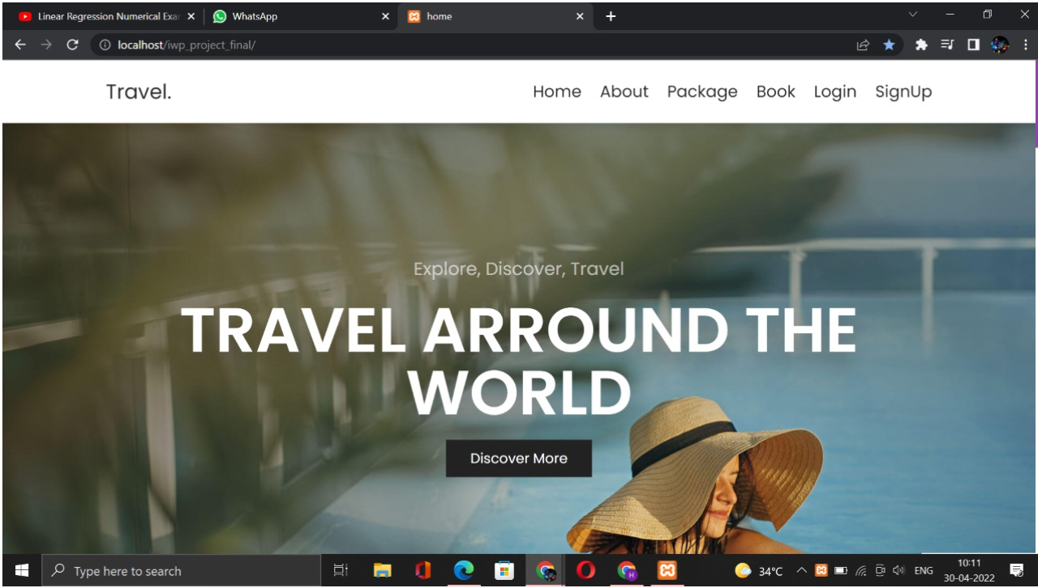

ABOUT US PAGE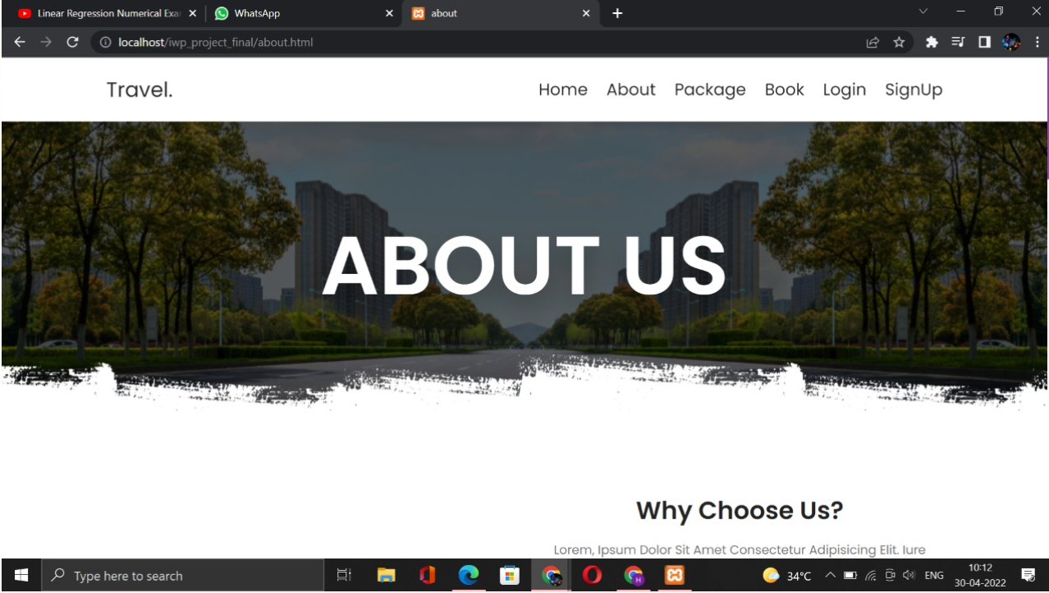

PACKAGES PAGE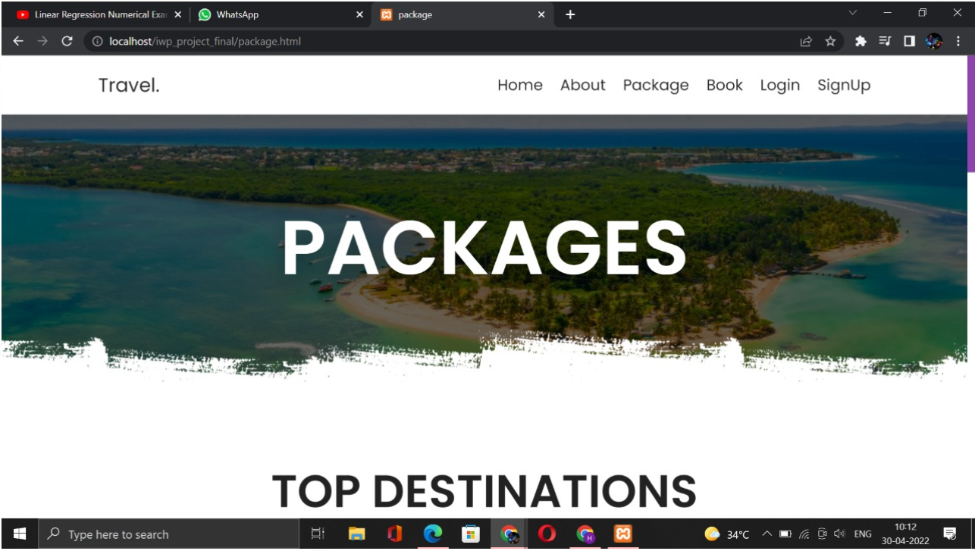

LOGIN PAGE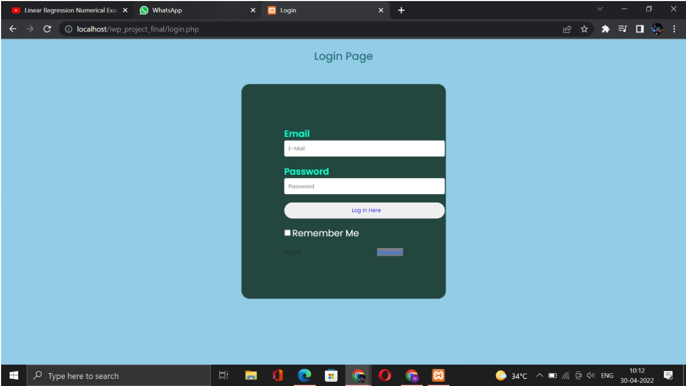

SIGN UP PAGE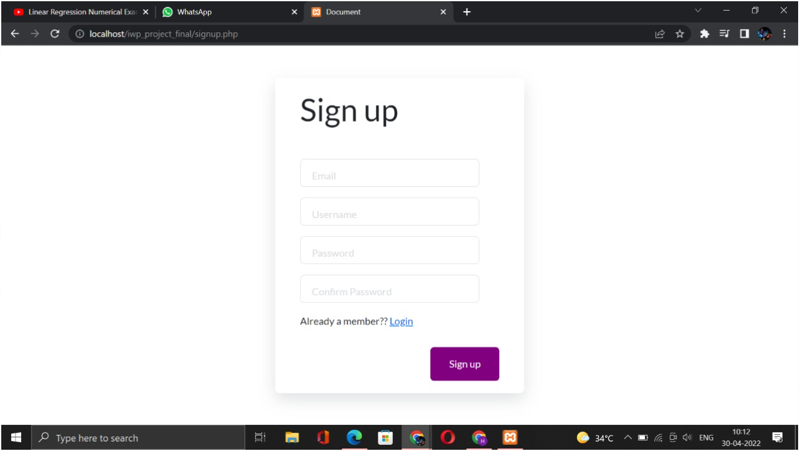

BOOKING PAGE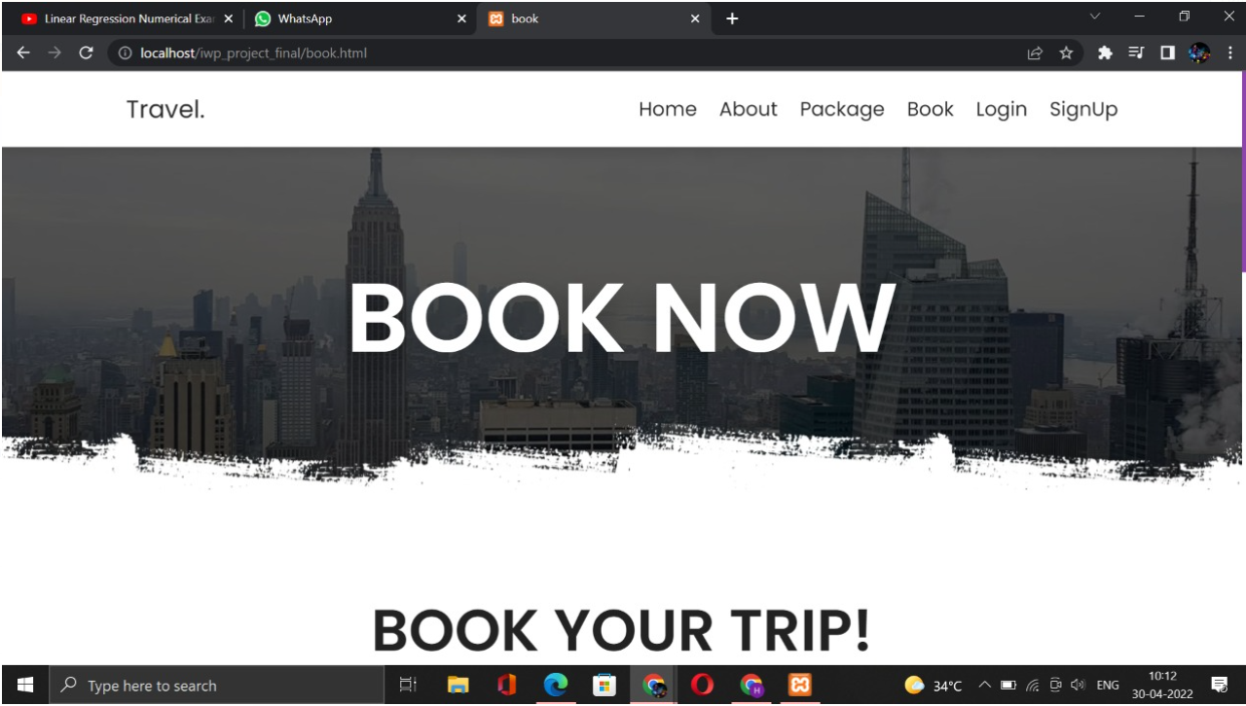

NORTH INDIA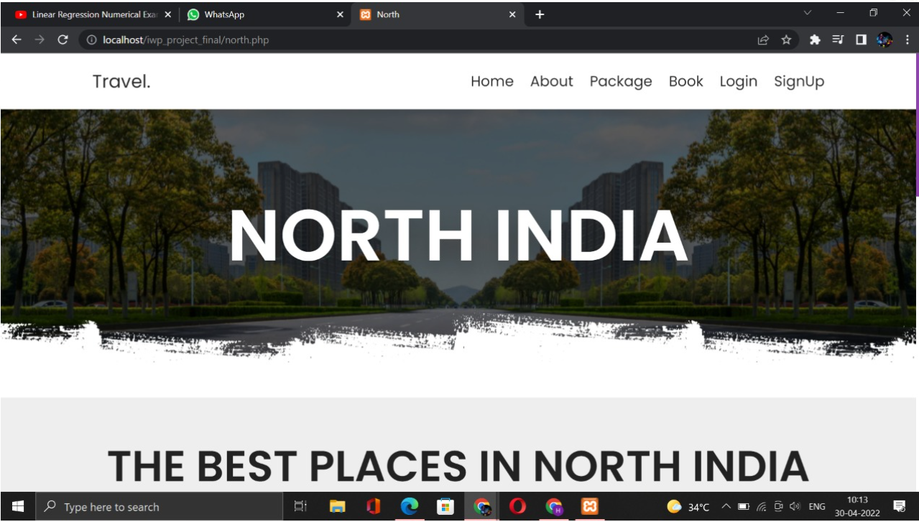

SOUTH INDIA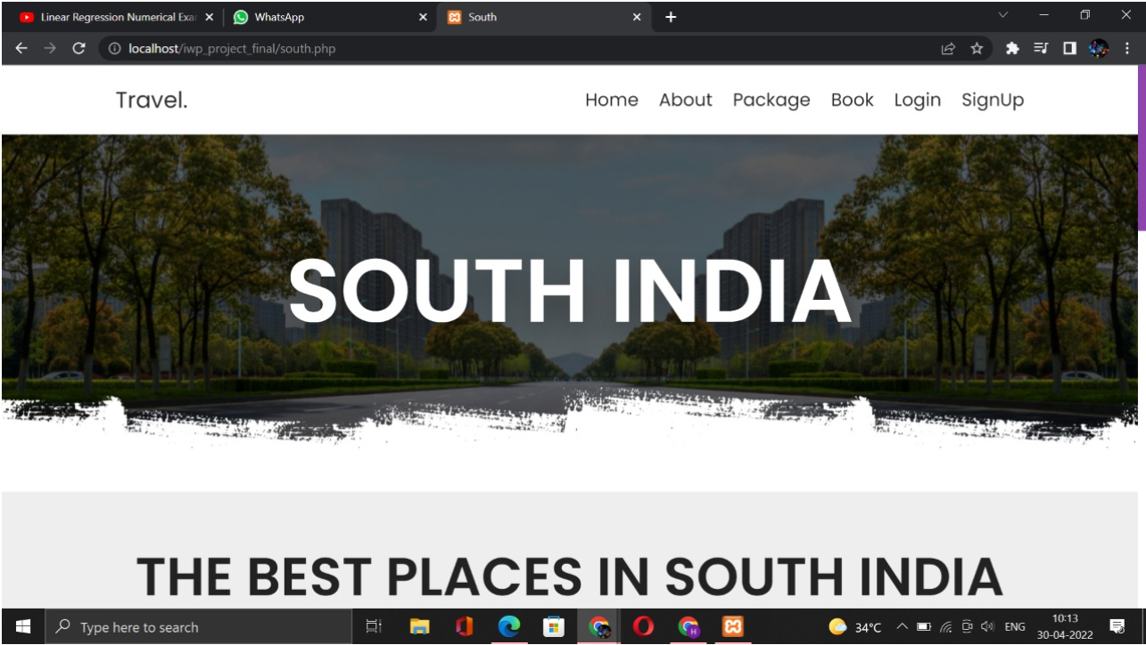

EAST INDIA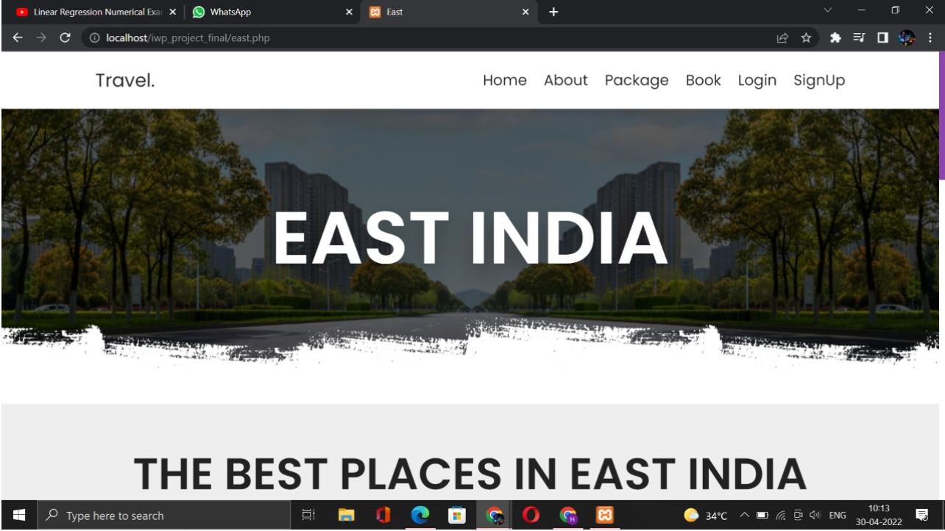

WEST INDIA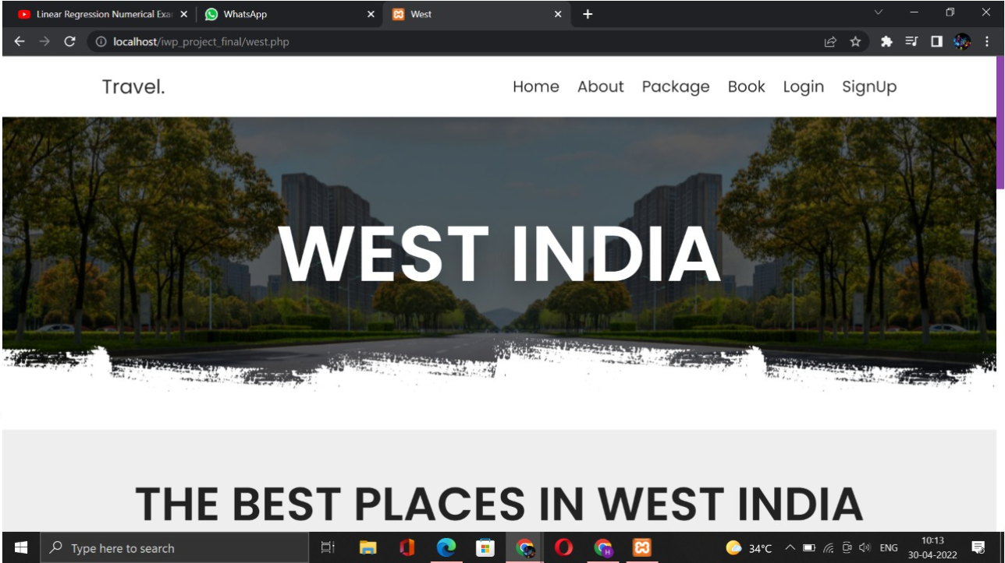

BOOKING PAGE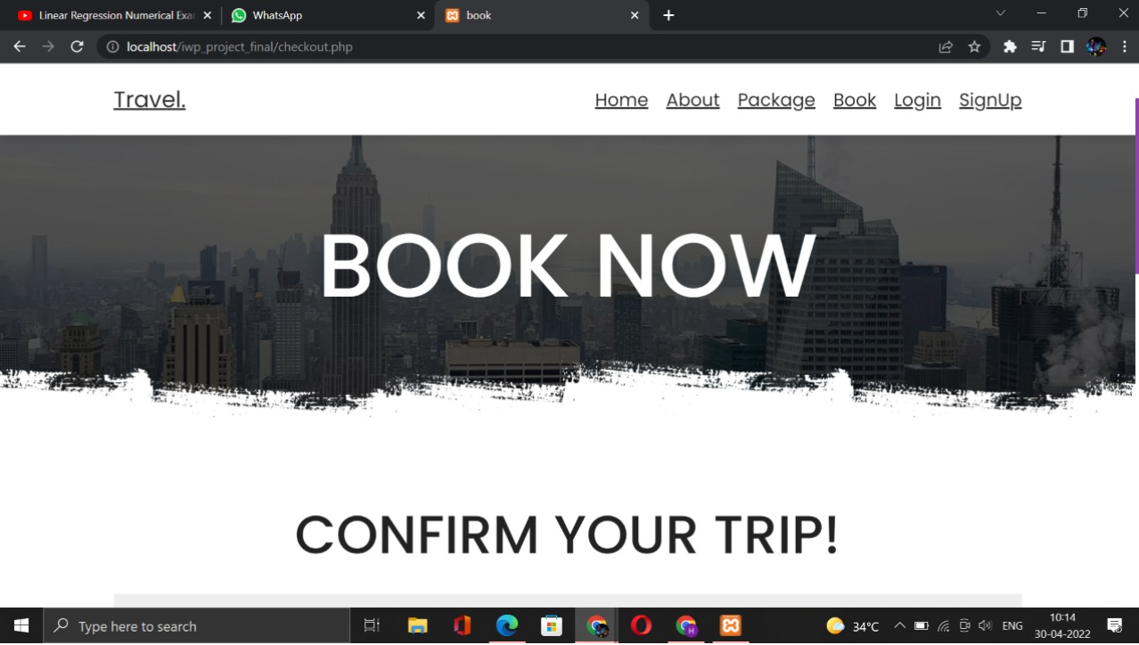

DATABASE-1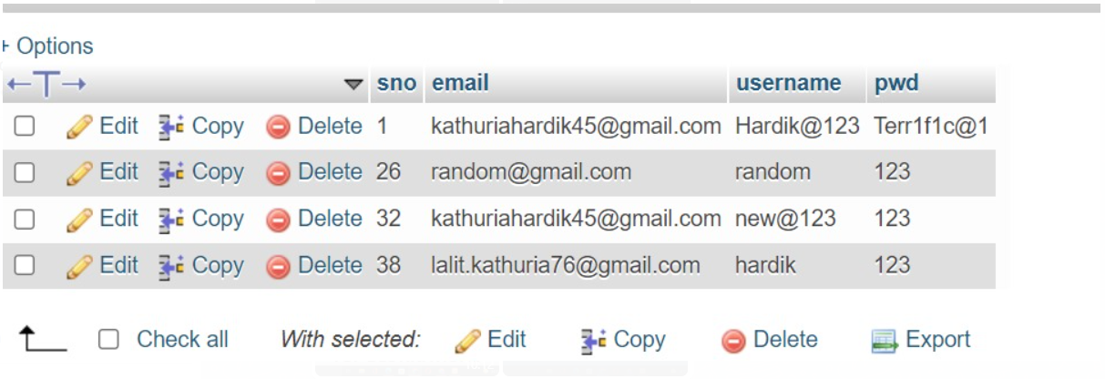

DATABASE-2